LABORATORY 3 (实验3)
Now that’s classy
深入学习类——实践

姓名: ____毛仁杰_______ 学号: ____20181738_______ 班级： 002

Objective（实验目的）
This week in lab you will work with an existing class type. The objective of the laboratory is to further explain how a class is constructed, to demonstrate how to overload an operator, and to show how a properly constructed class can be extended in useful ways without affecting any client programs that already use the class.
本周的实验是使用一个现有的类，实验目的是进一步介绍如何构造类，重载运算符以及怎样适当的创建类，以使得当扩展类的功能时，不会影响应用程序。
Key Concepts（核心概念）
_ Abstract data type (ADT)（抽象数据类型）
_ Facilitators（简化器）
_ Constructors（构造函数）
_ const member functions（常量成员函数）
_ Inspectors（检查器）
_ Auxiliary functions and operators（辅助函数和运算符）
_ Mutators（修改器）
_ Operator overloading（运算符重载）

9.1GETTING STARTED（准备开始）
_ Using the procedures in the introductory laboratory handout, create the working directory \lab3.
_ Many of the activities that are performed in the laboratory can be done in groups but you should work the exercises yourself.
-按照你的实验指导手册，在磁盘上创建一个工作目录\lab3。
-本实验项目可以小组的形式来进行，但是你自己必须亲自实践，自己练习。

9.2 ABSTRACT DATA TYPES（抽象数据类型）
Sophisticated problem solving requires that we develop our own representations
for the information to be manipulated. In object-oriented programming terminology, the representation and the operations to be performed on the representation form a data abstraction.
Data abstractions are developed using classes, functions, and operators. In developing an abstraction, we normally follow the information-hiding principle.
Enforcing information hiding through encapsulation helps to maintain the
integrity of the data (e.g., preventing an errant client application from setting
the denominator of rational number to zero). In addition, because client programs
use public methods, they are generally immune to changes in the implementation
of the abstraction.
A well-defined abstraction allows its objects to be created and used in an intuitive manner. Therefore, the programming syntax for the definition and manipulation of objects of an abstraction should have a form analogous to fundamental-type and standard-class objects doing comparable activities.
A well-defined class using the information-hiding principle coupled with the
appropriate library functions is an abstract data type or ADT.
The class Rational is an example of an abstract data type. In the following code segment, we display the result of summing 1/2 and 1/3.
Rational a(1,2); // a = 1/2
Rational b(2,3); // b = 2/3
cout << a << " + " << b << " = " << a + b << endl;
Rational addition and insertion have the same form as the corresponding display of the sum of two int or float objects would have. This analogous form would not be the case in traditional languages such as C or Pascal. In traditional languages, a programmer can neither have objects with methods nor extend existing operators to work with new types of objects. The programmer is forced to define functions and additional temporary objects. The resulting code is generally unnatural and awkward.
Your first task in the lab is to define two member functions Subtract() and Divide() to support Rational subtraction and division. The members are used by Rational auxiliary operators: minus (-) and slash (/). The two members Subtract() and Divide() are necessary because the auxiliary operators are not members and therefore have no access to the data member values.
_ Open the project file rational.dsw. Open the file ratextra.cpp. Scan through ratextra.cpp to see the definitions of auxiliary operators – and /. See that they invoke Rational member functions Subtract() and Divide().
_ Open the file rational.h. Make sure that Subtract() and Divide() are listed in the class division as public member functions. Make sure that - and / have been prototyped as auxiliary operators. Notice that they are prototyped outside the class definition.
_ The function body of the Rational member function Subtract() is incomplete. Remember the operation a/b - c/d equals (ad - bc)/bd. Complete this function.
_ The Rational member function Divide() needs to be completely written. Add this new function to ratextra.cpp. Remember the operation (a/b) / (c/d) equals ad / bc.
_ Open the file ratmain.cpp from the project rational.dsw. Observe what function main() does.
_Make and run project rational.dsw. Use the following inputs to test the program.
4/5 1/5
3/2 7/9
5/5 2/2
0/5 -1/5
_ Observe that 4/5 - 1/5 did not produce 3/5. Instead, it produced 15/25, which is equivalent to 3/5.
_ Close and save your modified rational.dsw project.

解决更为复杂的问题就需要开发自己的表达式来管理信息。在面向对象的程序设计术语中，表达式和在该表达式上所履行的操作形成数据抽象。
数据抽象是用类、函数和运算符开发的。在开发抽象数据类型的过程中，要遵循信息隐蔽原则。通过封装实施信息隐蔽有助于维护数据的完整性（例如放置有理数的分母为零）。此外，通过使用共有的方法，通常使用户程序可免于改变抽象数据类型的实现。
一种意义明确的抽象允许建立它的对象并以直觉的方法使用它。因此，对于抽象对象的定义和维护的编程句法在形式上类似于基本类型，而标准类对象做起来比较有活力。
我们将使用信息隐藏原则和适当的库函数相结合的意义明确的类称为抽象数据类型，即ADT.
例如，假设有个关于有理数的抽象Rational，而且我们要显示1/2和1/3的求和结果，则下一段代码将可以做到：
Rational a(1,2); // a = 1/2
Rational b(2,3); // b = 2/3
cout << a << " + " << b << " = " << a + b << endl;
这里要使得其插入形式与相应的显示两个int（整数）或float(浮点型)对象的形式相同。在传统的语言，也即非面向对象语言如C语言的情况下，就不会是这种类似的形式。在传统的语言中，程序员既不可能有与方法联系在一起的对象，也不可能将已存在的运算符进行扩充后与新类型的对象一起工作。程序员只能被迫定义函数利额外的临时对象，这样产生的代码常常即不自然也不灵活。
在本实验中，首先，你需要定义两个成员函数Subtract() 和 Divide()，用来实现Rational类的减法和除法运算。在后来的辅助运算符（—）和（/）会使用到这两个成员函数。并且这两个成员函数是非常必要的，因为辅助运算符不可以访问成员数据，却可以通过成员函数Subtract() 和 Divide()来访问。
（1）打开工程文件rational.sln，开源文件ratextra.cpp。快速浏览源文件ratextra.cpp查找辅助函数– 和 /，看看它们是如何调用成员函数Subtract()和Divide()的。
（2）打开头文件rational.h, 类中有public成员函数Subtract() and Divide()的声明，并且–和/辅助运算符函数也已做了原型声明。
（3）成员函数Subtract()的函数体并不完整，补充该函数。注意a/b - c/d 等于 (ad - bc)/bd。
（4）成员函数Divide()需要完全自己编写，并把它添加到ratextra.cpp中。注意(a/b) / (c/d)等于ad / bc。
（5）打开文件ratmain.cpp，观察main函数完成了什么功能。
（6）运行该工程。输入下面的值来测试该项目。
4/5 1/5
3/2 7/9
5/5 2/2
0/5 -1/5
（7）观察4/5 - 1/5并不等于3/5.而是等于15/25.
（8）关闭并保存文件。
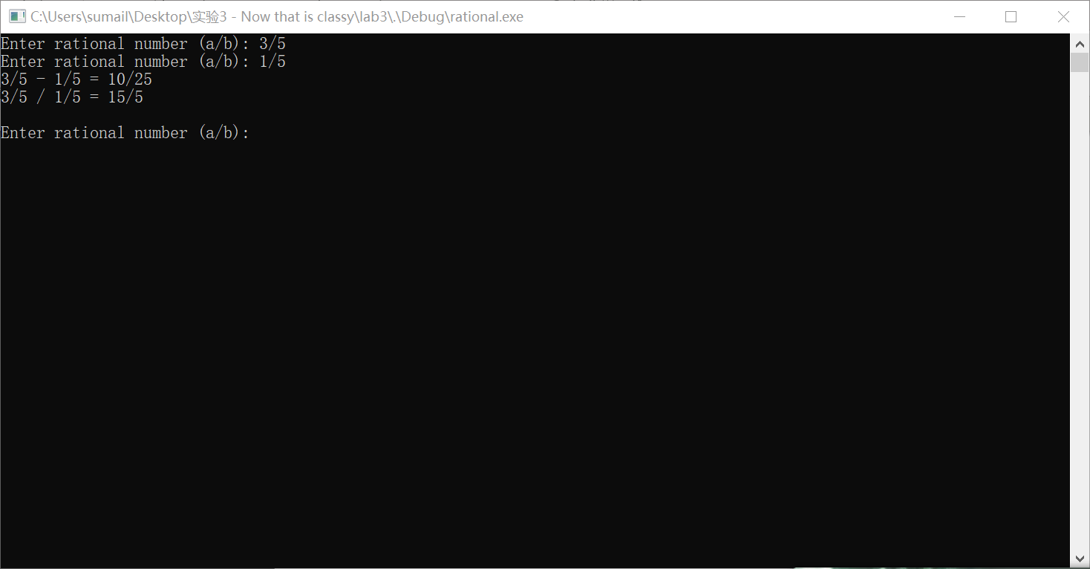

9.3REDUCING RATIONAL NUMBERS(化解有理数)
In a reduced rational the numerator and denominator do not have a common
divisor other than the factor 1. For example, the rational number 9/10 is reduced, while the rational number 8/10 is not. 8/10 can be reduced to 4/5. Producing rational numbers that are not reduced is unsatisfactory. With nonreduced numbers, determining whether two rationals are equal is difficult. In addition, the numerators and denominators of rationals that are being computed can get larger than they need to be, which can cause unnecessary overflow problems.
You are to modify the Rational class so that all arithmetic operations return a
reduced result. A simple way to reduce a fraction is to divide both the numerator
and denominator by their greatest common divisor (GCD). A simple algorithm
for computing the GCD of two positive integers m and n follows.
1. Let r be the remainder of m divided by n.
2. If r is zero, the algorithm terminates and n is the GCD. If r is not zero, then
set m = n and n = r; and return to step 1.
A C++ function that implements this algorithm is contained in gcd.cpp, and
the interface is in gcd.h. Examine the function and make sure it corresponds to the algorithm. Before using a function, you should make sure that the function works as advertised. One way to do so is to supply a test harness and test the function. Before making the modifications to the rational class, write a test harness and test gcd.cpp. Your test program should prompt for two integers
and print the greatest common divisor.
_ Open the file gcdtest.cpp and put your the test code inside function main().
_ Make and run the project gcd.dsw. This project uses gcdtest.cpp.
_ Run your program on the following inputs to make sure function gcd() is
working correctly.
12 6
55 44
15 0
461952 116298
_ Open the reduce.dsw project.
_ Make the changes to rational.h and rational.cpp so that reduced rationals are used. You will need to develop a new protected member Rational function Reduce(), whose class prototype is void Reduce();
Recall that the implementation of Reduce() should go in the file rational.cpp, while the interface to Reduce() is part of the Rational class definition in rational.h.
_ Add the prototype for Reduce() to the class Rational in rational.h.
_ Include the library gcd.h at the beginning of rational.cpp.
_ Add the implementation of Reduce() to the file rational.cpp. Note
that in the implementation file when defining Reduce() you must begin the definition in the following manner: void Rational::Reduce()
Because the implementation of Reduce() is not contained with its class definition, you need to prepend the function name Reduce with its class name Rational through the use of the scope resolution operator. This syntax tells the compiler which function Reduce() we are defining—in this case the one that is a member function of the class Rational.
_ Show your laboratory instructor the change you made to rational.h and your implementation of Reduce() in rational.cpp. Remember that gcd() expects that both of its parameters are positive. Therefore, some case analysis is required in Reduce().
_The next step is to decide where and when to call Reduce(). Our implementation
of the Rational class requires only two calls of Reduce() in the Rational member functions. One of these calls is in the nondefault constructor.
_ Examine the Rational implementation and determine where to place the
other call to Reduce(). Tell your laboratory instructor where you want to place this call. Hint: the call is not added to SetNumerator() or SetDenominator().
_ After making all the necessary changes, demonstrate that your implementation of the Rational class produces reduced results. Build and run the project reduce.dsw on appropriate inputs. The test harness for this project is rattest.cpp.
_ Close the project reduce.dsw.

在一个简化了的有理数中，分子分母除了公约数1并没有其他公约数。例如，9/10是简化了的，而8/10就不是。8/10还可化简为4/5.没化简的有理数并不能如意，带有未约去的数值两个有理数则很难进行比较。并且，有理数的分子分母在计算中会变得比实际中的大，这会造成不必要的数据溢出问题。
你需要做的是修改Rational类，以便于所有的计算操作将返回一个简化了的结果。一个简单的方法是将有理数的分子与分母都除以他们的最大公约数。如下是一个简单的计算两个数的最大公约数的算法：
- r用来存储m对n求余。
- 如果r等于0，算法终止，并且n为最大公约数。如果r不为0，则重新设置令m=n,n=r,再返回第一步循环运行。
gcd.cpp文件中有对该算法的实现，检查该函数并确保该函数与以上算法相符。在用这个函数之前，请先对该函数进行测试，确保按预期运行，一种方法是提供一个测试用例，用以测试该函数。在对Rational类进行修改之前，先写一个测试用例，测试gcd.cpp文件进行单元测试。你的测试程序要提供两个整数并输出最大公约数以验证：
- 打开gcdtest.cpp，将你的测试代码放进main函数中。
- 运行程序输入下列值确保gcd()函数正确运行。
12 6
55 44
15 0
461952 116298
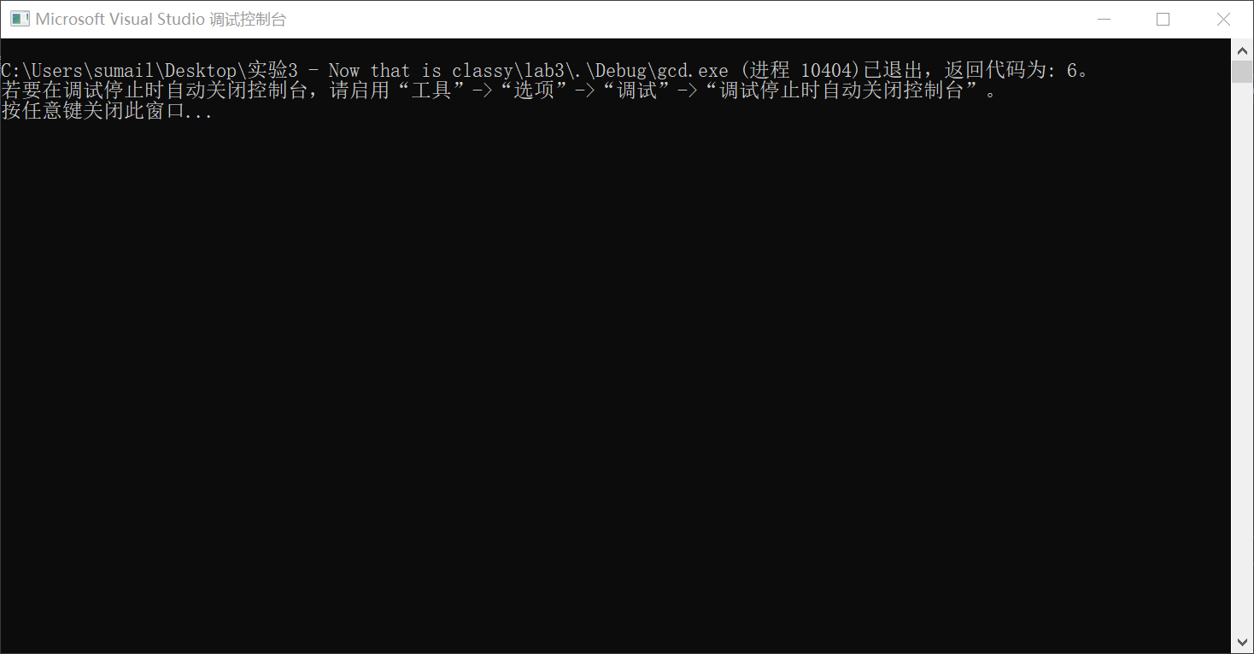

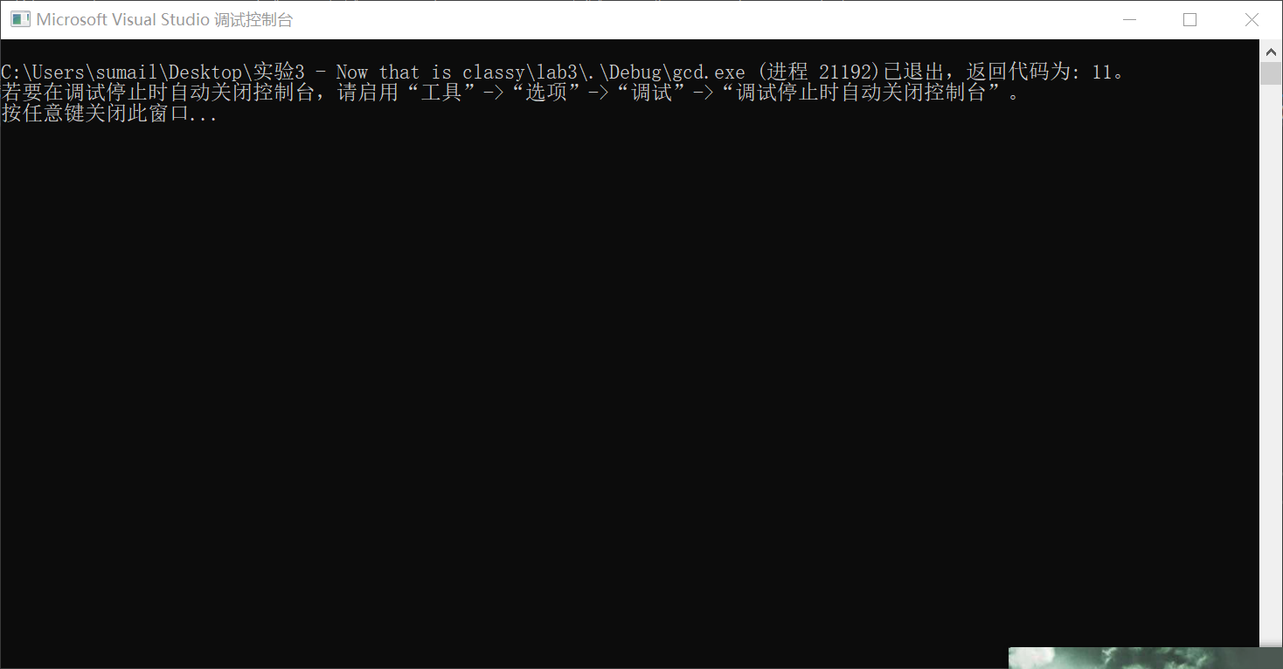
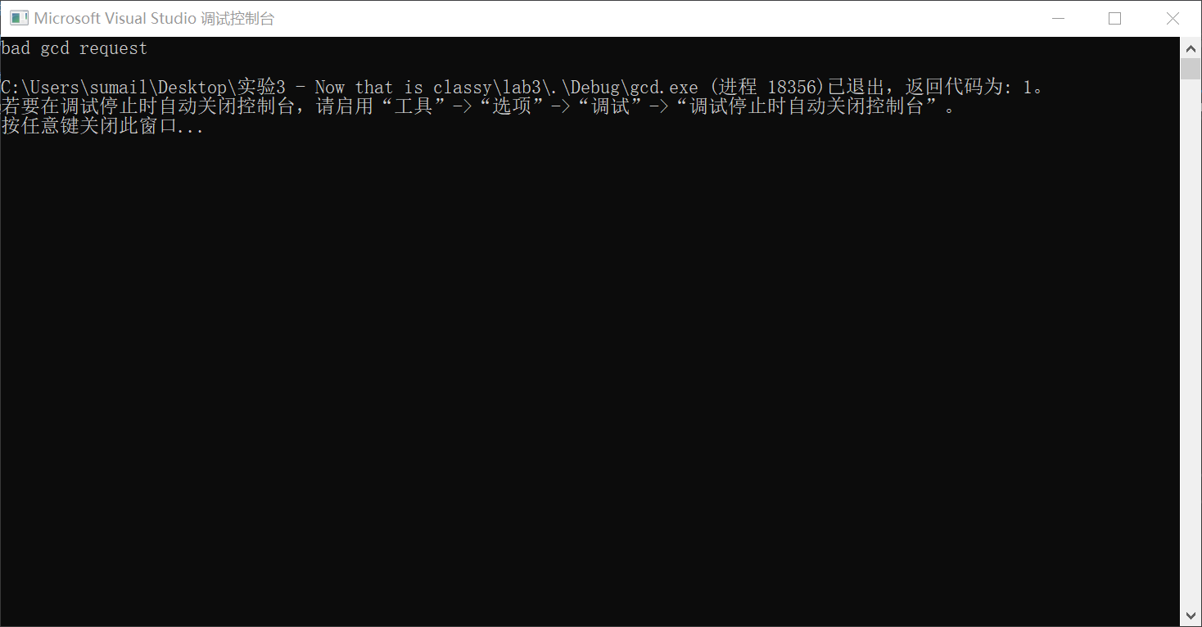
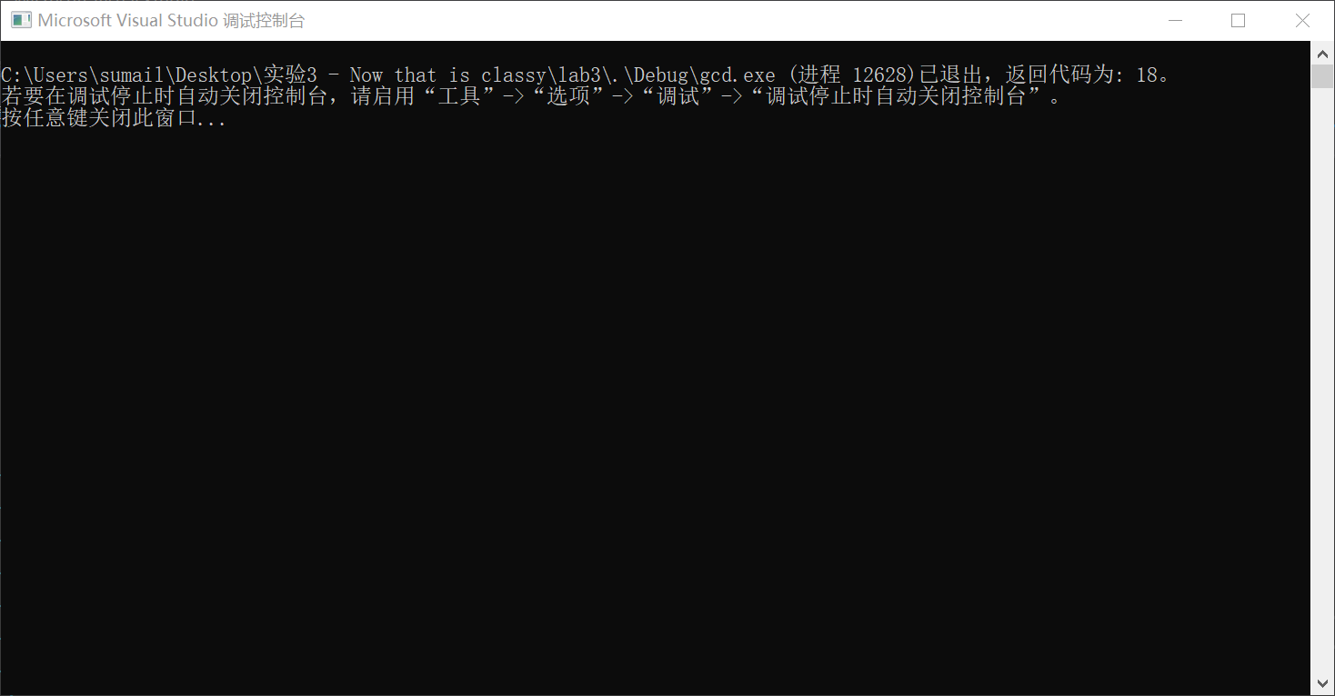
- 打开reduce.sln工程。
- 对rational.h和rational.cpp文件作修改，实现简化了的有理数数据类型。你需要开发一个新的protected的Rational成员函数Reduce().该函数原型为void Reduce().
注意Reduce()的实现应该放入rational.cpp文件中，而接口Reduce()放在头文件rational.h中。步骤如下：
_ 在rational.h中添加Reduce()函数原型。
_ 在rational.cpp中包含gcd.h头文件。
_ 将Reduce()函数的实现添加到rational.cpp文件中。注意在定义Reduce()函数时必须按照如下方式定义：
void Rational::Reduce()
因为Reduce()的实现并不是在类定义中实现的，你需要在Reduce函数名前用范围解析操作符和类名（这里是Rational）。这个语法告诉编译器我们定义的Reduce()函数是类Rational的成员函数。
_ 把你对rational.h文件做的修改和对reduce()函数的实现给你的实验指导老师检查。注意：gcd()需要的参数必须为正整数。因此在Reduce()函数中还需要对参数作分析。
下一步要决定在什么地方什么时候调用Reduce()函数。我们对Rational类实现的成员函数有两处需要调用了Reduce()函数。一处是自定义的构造函数中。
_首先查看Rational实现中，决定在哪个地方需要放置你对Reduce函数的第二次调用。提示：不在SetNumerator()和SetDenominator()函数中进行对Reduce()函数的调用。
_在做这些必要的修改后，验证你的Rational可实现简化有理数的结果。运行reduce工程，并输入适当的值。对这个工程的测试用具就是rattest.cpp。
_关闭reduce工程。

9.4 OVERLOADING OPERATORS(运算符重载)
For the next part of the laboratory, you are to develop relational auxiliary operators for the class Rational.
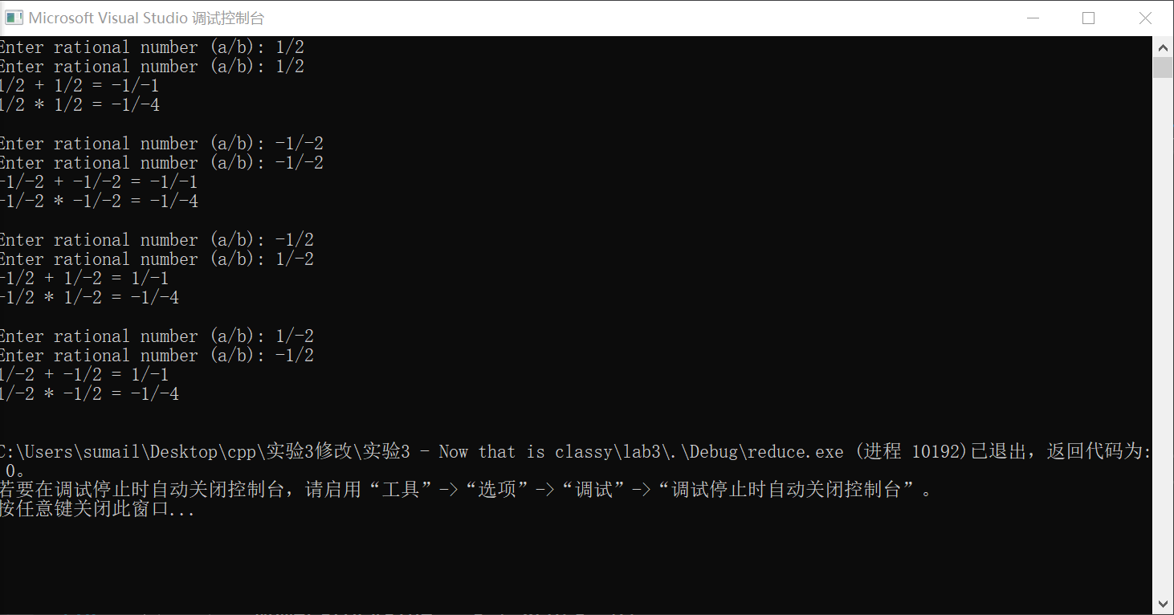
不知道为什么正数会用两个复数表示，运算结果没有问题
Rationals a/b and c/d are equal if ad equals bc. Rational a/b is less than rational
c/d if ad is less than bc. Rational a/b is greater than rational c/d if ad is greater
than bc.
The overloaded relational auxiliary operators will use a public member facilitator
Compare() that expects a single constant reference parameter r as its parameter. Facilitator Compare() returns a negative value if the invoking object is less than r, it returns 0 if the invoking object is equal to r, and it returns a positive value if the invoking object is greater than r.
You can use member function Compare() to implement the relational operators
==, < and >. For example Rational object s is less than Rational object
t if s.Compare(t) is negative.
_ Open the project comp.dsw.
_ Make the changes necessary to both rational.h and rational.cpp to make Compare() a member function of the Rational ADT. Remember that the interface (i.e., the prototype) goes in rational.h and the implementation of the overloading goes in rational.cpp.
_ Make the changes necessary to both rational.h and rational.cpp to make ==, < and > auxiliary relational operators of the Rational ADT.
Remember that the interface (i.e., the prototype) goes in rational.h and the implementation of the overloading goes in rational.cpp.
_ Test your auxiliary operators by making and running the project comp.s. Demonstrate your program to a laboratory instructor.
实验的接下一步：为你的Rational类开发辅助关系运算符。
当ad=bc时有理数a/b、c/d相等，如果ad小于bc，则a/b小于c/d，若ad大于bc则a/b大于c/d。
对有理数的辅助关系运算符的重载需要使用一个公有成员函数Compare()，这种函数称为简化器(Facilitators)。该函数有一个const引用型形式参数r。Compare()的返回值为：当有理数的值小于r时返回一个负数，当等于r时返回0，当大与r时返回一个正数。
你可以通过简化器Compare()来实现关系运算符==、<和>。例如如果该有理数s的值小于t,则s.Compare(t)返回负数。
_打开工程comp.sln。
_在rational.h和rational.cpp文件中作必要的修改，完成对Compare()的声明和实现。注意：在rational.h中声明函数原型，在rational.cpp中完成函数的实现。
_在rational.h和rational.cpp文件中作必要的修改，完成对辅助关系运算符==、<、>的重载，注意：在rational.h中声明函数原型，在rational.cpp中完成函数的实现。
_通过运行工程测试你的辅助关系运算符。将结果展示给你的指导老师。
